***Storybook Farm***

**Valentine’s Day Party**

* Popcorn station
* Treasure hunt that leads to different stations
  + The kids are “running late” and have to get to the queen of hearts
* Craft for kids to take home to parents
* Have games and activities out
  + big checkers
  + hula hoops
  + face paint
  + Hay ride
* Queen of Hearts and Alice in Wonderland
  + Have stations for each of her adventures
    - She falls down the rabbit hole
    - Eat me, drink me (big and small)
    - Tea party
    - The queen of hearts and painted flowers

Station #1 Rabbit Hole

* Enter through the rabbit hole
* Eye spy finding all the things alice sees in the rabbit hole

Station #2 Eat Me Drink Me (Tweedle Dee and Tweedle Dum’s Treats)

* Kids can drink water and eat treats
* Also have popcorn station
  + Toppings such as chocolate chips, sprinkles, conversation hearts, and m&ms

Station #3 Tea Party

* Mad hatter hat toss on the tea cup
* Teacup water race

Station #4 The Queen of Hearts and Painting Flowers

* Craft: painting flowers
* And/or make their own mad hatter hat

If time allows could have a photo op with alice in wonderland props

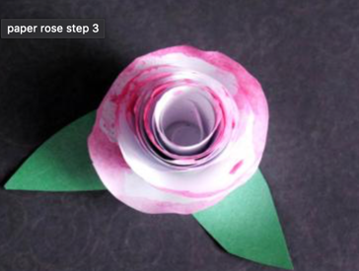

photo op props

mad hatter hat craft option

paper teacup for games

paper flower for crafts to paint