***Storybook Farm: Spring Theme***

Summer Olympics 2020: The Characteristics of a Champion

* Tokyo
* “the Tokyo Games will use as many existing competition venues as possible, namely those built for the Games in 1964, the Baji Koen Park for equestrian events”
* correspond Olympic event to sessions for the week and center games and activities around them
  + maybe emphasize
    - equestrian dressage
    - equestrian eventing
    - equestrian jumping
* end of the season could be the “finish line”
* the kids are the athletes receive gold medals
  + maybe make it a craft with clay and paint toward the end of the semester
* incorporate the flags of the countries
  + use it as a learning opportunity for the kids

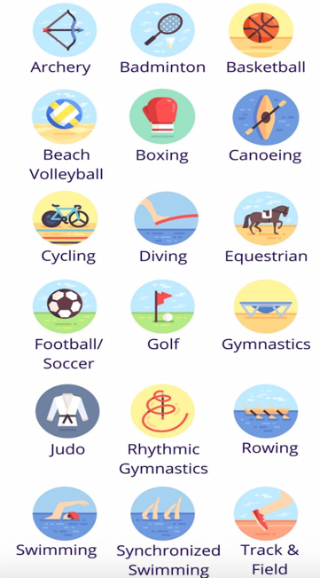

Safari

* Kids go on a quest through the safari
  + Kenya and Tanzania Africa, etc.
  + Scavenger hunt to different countries
  + Track down different animals (animals hidden in barn?)
* Incorporate characters
  + Simba (lion king)- lion
  + Rafiki (lion king)- monkey
  + Dumbo- elephant
* Kids can learn about the difference between a farm, the zoo, and the wild (safari)
* Each week the kids travel to a new country and learn about the animals there
  + Activities each week could revolve around the safari animals, travelling to countries, what those countries are like
    - Learning opportunity
* Kids could make their own safari hats as a craft one day towards the beginning of the season that they can bring and wear throughout the rest of spring

